**Week 5 Math**

**1** #7

### Problem: Reverse Integer

### 

**Description:**

Reverse digits of an integer.

**Example1:** x = 123, return 321  
**Example2:** x = -123, return -321

**###Have you thought about this?**

Here are some good questions to ask before coding. Bonus points for you if you have already thought through this!

If the integer's last digit is 0, what should the output be? ie, cases such as 10, 100.

Did you notice that the reversed integer might overflow? Assume the input is a 32-bit integer, then the reverse of 1000000003 overflows. How should you handle such cases?

For the purpose of this problem, assume that your function returns 0 when the reversed integer overflows.

**2** #8

### Problem: String to Integer (atoi)

### Description:

Implement atoi to convert a string to an integer.

**Hint:** Carefully consider all possible input cases. If you want a challenge, please do not see below and ask yourself what are the possible input cases.

**Notes:** It is intended for this problem to be specified vaguely (ie, no given input specs). You are responsible to gather all the input requirements up front.

**3** #12

### Problem: Integer to Roman

### Description:

Given an integer, convert it to a roman numeral.

Input is guaranteed to be within the range from 1 to 3999.

**4** #29

### Problem: Divide Two IntegersDescription:

Divide two integers without using multiplication, division and mod operator.

If it is overflow, return MAX_INT.

**5** #43

### Problem: Multiply Strings

**Description:**

Given two numbers represented as strings, return multiplication of the numbers as a string.

Note: The numbers can be arbitrarily large and are non-negative.

**6** #50

### Problem: Pow(x, n)

### Description:

Implement pow(*x*, *n*).

**7** #168

### Problem: Excel Sheet Column Title

### 

**Description:**

Given a positive integer, return its corresponding column title as appear in an Excel sheet.

For example:

1 -> A

2 -> B

3 -> C

...

26 -> Z

27 -> AA

28 -> AB

### 8 #172

### Problem: Factorial Trailing Zeroes

### Description:

Given an integer *n*, return the number of trailing zeroes in *n*!.

**Note:**Your solution should be in logarithmic time complexity.

**9 #**223

### Problem: Rectangle Area

### Description:

Find the total area covered by two **rectilinear** rectangles in a **2D** plane.

Each rectangle is defined by its bottom left corner and top right corner as shown in the figure.

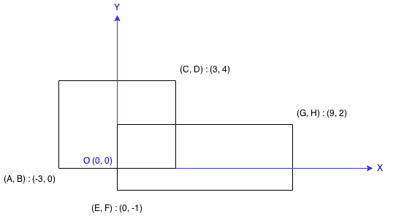

Assume that the total area is never beyond the maximum possible value of **int**.

**10** #231

### Problem: Power of Two

**Description:**

Given an integer, write a function to determine if it is a power of two.